# W03 Project: Rafting Site – Planning Document

## Logo.

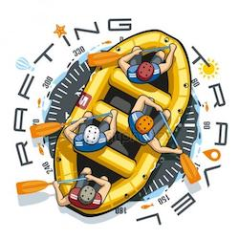

## Color palet.

* primary-color: #FADDC7 - champagne pink
* secondary-color: #EFEFD0 - Beige
* accent1-color: #007FE0 - Azure
* accent2-color: #61ACE5 – Argentinian blue

[Color Palet Link](https://coolors.co/faddc7-efefd0-007fe0-61ace5).

## Fonts.

* Heading-font: Kaushan Script.
* Text-font: Montserrat